INTRODUCTION:
The Ventura meter used in this experiment consists of successive converging, uniform and diverging sections equipped with pressure taps at selected locations.
A Ventura meter is a device for determining the flow-rate of a fluid down a pipe. One measures the pressure difference between the venture inlet and neck, and from this the flow-rate can be determined.

OBJECTIVE:
To study the variation of C_{od} and discharge with respect the head by plotting the following graphs
Vs
Vs h
Taking and h on x-axis and on y-axis
THEORY:
Venturimeter is a device used for measuring the rate of flow of a fluid through a pipe. The basic principle on which a venturimeter works is that by reducing the cross sectional area of the flow of passage, a pressure difference is created and the measurement of the pressure difference enables the determination of the discharge through a pipe.
The Venturimeter consists of three main parts as shown in fig 1.
- Convergent cone
- A Cylindrical throat
- Divergent cone
The inlet section of the venturimeter is of the same diameter as that of the pipe, which is followed by a convergent cone. The convergent cone is a short pipe, which tapers from the original size of the pipe to that of the throat of the venturimeter. The throat of the venturimeter is a short parallel-sided tube having uniform cross sectional area smaller than that of the pipe. The divergent cone of the venturimeter is a gradually diverging pipe with its cross sectional area increasing from that of the throat to the original size of the pipe. At the inlet section and at the throat, (i.e., section 1 and 2) pressure taps are provided to measure the pressure difference. By applying the Bernoulli equation to the inlet section and at the throat, (i.e., section 1 and 2) an expression for the discharge is obtained.
Water is allowed to flow through the meter at different rates ranging from zero to the maximum and the corresponding pressure differences shown in the manometer are noted. The actual discharge A is determined using the measuring tank and the stop watch.
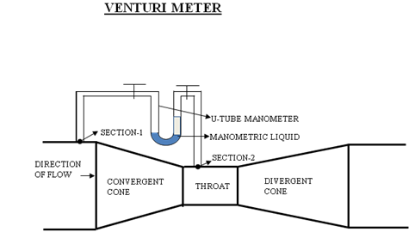

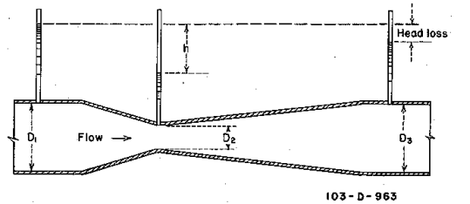
Actual discharge (A) = 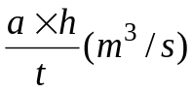
Where
a – Area of measuring tank in cm²
h – Height differences in pyrometer in cm
t – Time to collect water for a height difference of h cm, measured in Seconds
Theoretical discharge is given by
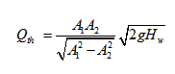
Where
A₁ – The area at inlet side in cm²
A_{2 –} The area at throat in cm²
H_{w –} Head difference in the manometer, converted to cm of water
g – Acceleration due to gravity (9.81 m/sec²)
Coefficient of discharge is given by
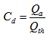

OBSERVATIONS AND CALCULATIONS:
Plan area of the tank A =
Sl. no | Time for 10cm rise of water level (s) |  |  | Actual discharge A cm³/s | Differential head in cm. of mercury |  |  | Differential head in cm. of water. | Theoretical discharge Q_{th,}cm³/s. | Coefficient of discharge C_{od}
Sl. no |  |  |  | Actual discharge A cm³/s | h₁ | h₂ | h₁- h₂  H_{ug} | Differential head in cm. of water. | Theoretical discharge Q_{th,}cm³/s. | Coefficient of discharge C_{od}
Sl. no | t₁ | t₂ | t_{m}
1
2
3
4
5
MANUAL:
Start the experiment by pressing the start button with keeping default values of inlet die of venturimeter and throat die and rise of water level H and discharge ,then pass the experiment after few cycles and note the observations.
Observations1:
1) Allow the water to flow from the inlet or gate valve through the pipe to the convergent cone, then the level of the pyrometer rises up to some height.
2) Then the measure the pressure head in the pyrometer.
Observation2:
1) Then allow the water to flow from the convergent to throat and from the throat to the divergent cone.
2) Hen level in the pyrometer rises up to some height. Rising depends upon the rate of flow of water.
Observation3:
1) Then allow the water to flow in to the collecting through the outlet and after filling some amount of water in the collecting tank ,the water level in the collecting is increased and the measure the time taken to collect the water for every 10cms rise.
2) Repeat the experiment by changing the discharge, inlet die and throat and rise of water level.

RESULT: Coefficient of discharge of venturimetre Cod =

MAINTENANCE:
1. After completing the experiment close the inlet valve and open all the gate valves and needle valves to vent any air trapped inside and then close them.
2. Drain the water from measuring tank after completing the experiment.
QUIZ:
- Venturimeter is used to measure average velocity
- true
- false
- Angle of contraction is more than angle of diversion
- true
- false
- The inlet length of the Venturimeter’s greater than outlet pipe
- true
- false
- Actual discharge is obtained by (A)= a x h/t
- true
- False
- Coefficient of discharge is calculated by =
a) True
b) False

REFERENCE:
- FLUID MECHANICS - RK BANSAL
- EXPERIMENTS ON FLUID MECHANICS - SARABJIT SINGH
- WIKIPEDIA
- The constructor- http://theconstructor.org/

PART – 2
ANIMATION STEPS
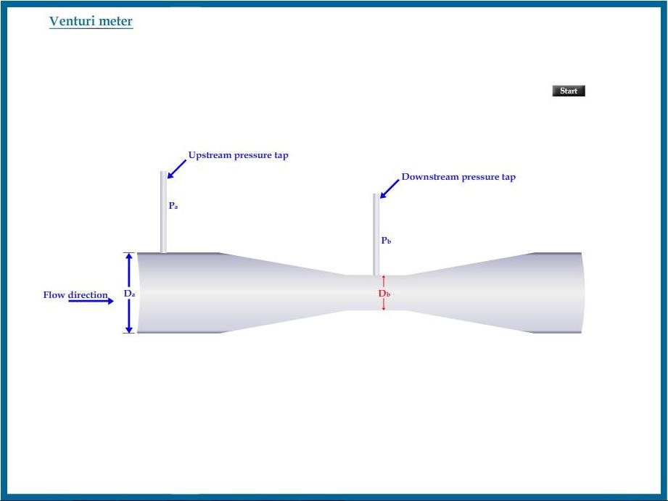

PART – 3
VIRTUAL LAB FRAME

